# 02/21/2019 - Capstone Meeting Notes

**Discussions:**

* Emissivity of the solar panels, 6061-T6 anodized aluminum and the PCBs
  + Consider the other boards in our thermal analysis, and approximate them outputting ~1W of heat
  + Clear/hard anodization, specifically look at other colors to suggest
    - Black ano on the whole thing
  + No sandblasting in the machining process
* Create a capstone folder in the PSAS shared drive
* Under the oresat-thermal **branch** in the oresat github, create a **repo** where we post **ALL** of our stuff. Everything down to the individual MATLAB scripts
  + Make sure that we leave explicit notes about our files about what a sim or code is trying to accomplish for the people that come after us, or when we are looking back
  + Feel free to create commits in the GitHub as well
* Make sure we know what our deliverables
  + Hand off meeting - 1+ hour QA/discussion with the OreSat team about what we have done for the project, what should be next and informing the next gen of people working on this project what is up
* PCB conduction measurements
  + Use IR camera from professor Gall’s lab to map conduction through the PCB
  + RTDs recommended, over the shelf, just a couple hundred dollars sounds good
  + Find logger software for the RTDs

**Progress:**

* Parker
  + Took the 1D plate sim and expanded to 30,000 time interval
    - Pretty sure ANSYS just died during this, even though I don’t have full confirmation
  + After attempting the 30,000 time interval sim, I reduced to 3,600 seconds and gathered meaningful results:
    - [Here](https://imgur.com/a/8komiaQ) is a gif of the meat of the transient state (55 seconds - 559 seconds)
    - Here’s proof why the sim is correct:

**Heat convergence graph**: 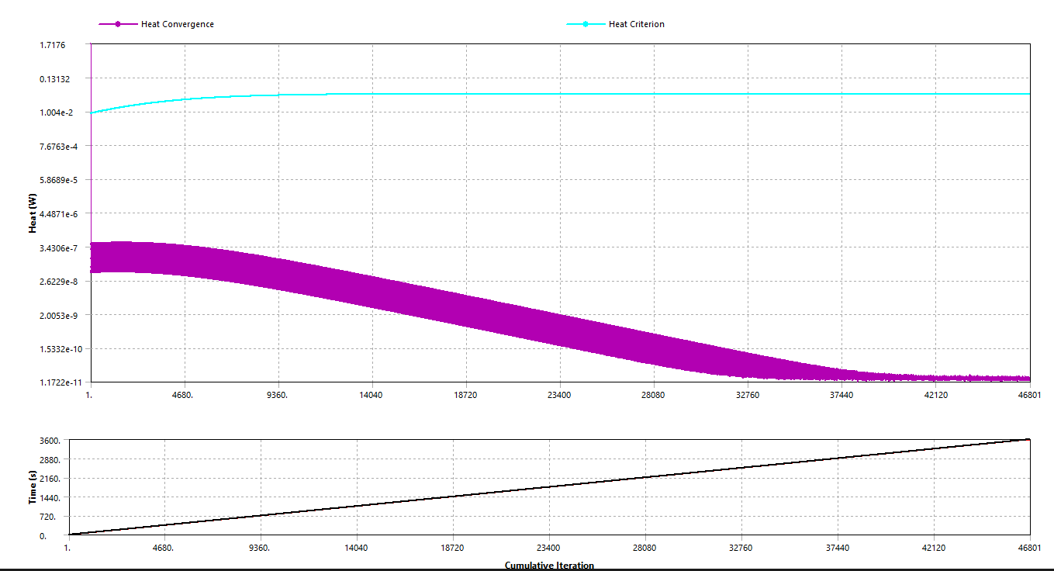

* + **Thermal error**: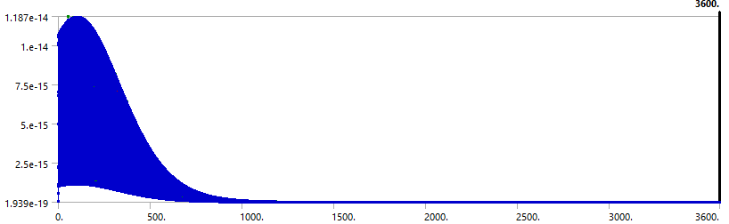
  + 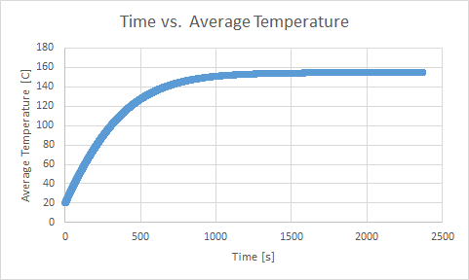
    - pls excuse the figure title
  + I have 2 PCBs for us to use for us to use for conduction testing: a 2-layer and a 4-layer
    - Andrew has asked for testing on both boards as its still being debated whether to use a 2-layer or 4-layer PCB
    - Free to use OreSat parts for any and all testing
  + Upcoming needs:
    - Emissivity and view factor values, re-run maths and sim with these correct values
    - Refining new sims Griffin has made
* Katherine
  + https://www.design1st.com/Design-Resource-Library/engineering_data/ThermalEmissivityValues.pdf
    - Emissivity of anodized aluminum of various colors - Table 4
* Tom
  + Researched thermal sensors
  + Matlab-ed
* Jeremy
* Griffin
  + Ran a 2d plane simulation to confirm our ODE. Ended up being only 7 K off!
  + Began setting up a rough simulation of a hollow cube just to see what would happen. Should probably be refined a little.
  + Planning on running a 2d plane model using the actual oresat wall geometry.
* Tyler
  + Finally got to finish up module 4 but work took up a lot of time this week so that was all I got to do.

**Action Items:**

* **Emissivity of the solar panels, 6061-T6 anodized aluminum and the PCBs**
* **Order temp sensors**
* **Meet with Stu about IR camera**

**Important notes for Ansys:**

* We should fully dissect each sim before we move on to the next one, there is still a bit more juice we can squeeze from the 1D wall.
  + Error analysis and checking for convergence is critical for this kind of work
* Large time intervals will need to be done on the PSAS PC, as I will be able to assign more CPUs to the solver whenever we’re running larger sims

**Important dates:**